**Chapter 4 - QUIZ – VTP**

1. How does VTP affect VLAN administration?
2. Port to VLAN assignments for an entire VTP domain can all be done on a single switch.
3. VLAN's are only visible on switches that have ports assigned to them.
4. VTP propagates VLAN numbers, but not names, to all switches in a VTP domain.
5. VTP is required to allow VLAN naming across switches.
6. VTP propagates VLAN names to all switches in a VTP domain.
7. A Catalyst switch must be in which VTP mode to delete or add VLAN's to a management domain?
8. client
9. server
10. domain
11. transparent
12. designated
13. What is the purpose of VTP transparent mode?
14. Permits VLAN creation on a single transparent switch and subsequent propagation to all other VTP switches.
15. Allows propagation of extended-range VLAN's.
16. Makes VTP traffic transparent to other devices by allowing VLAN's other than VLAN 1 to act as the management VLAN.
17. Enables VTP advertisements to pass through a non-participating switch..
18. Refer to the following diagram description to answer the question. Switches A and B connect via a trunk and are running VTP. However, switch B is not getting VLAN update information. What could cause this problem?



1. FastEthernet cannot be used for trunking.
2. The switches are not set to the same VTP mode.
3. The VTP domain name is not the same on both switches.
4. The configuration revision number does not match on both switches.
5. A switch in a VTP domain sends an advertisement request. What is the response?
6. A configuration status reply is issued from the closest client switch.
7. A three-way handshake establishes a configuration session with the VTP server.
8. Summary and subset advertisements are sent by the VTP server.
9. The configuration version number is set to zero, and all switches in the domain issue advertisements regarding the state of their VLAN's.
10. Match the command listed on the left to the associated description. (Not all options are used.)

|  |  |  |  |  |  |  |
| --- | --- | --- | --- | --- | --- | --- |
| A. | VTP mode client | 🡺 |  | | Specifies that the switch cannot create or delete V LAN's shared in VTP advertisements. | |
| B. | VTP domain LABS | 🡺 |  | | Configures the name used to determine which switches belong to the same management group. | |
| C. | VTP pruning | 🡺 |  | | Restricts flooded traffic to trunk links that the traffic must use to reach destination devices. | |
| D. | VTP mode server | **X** |  |  | |
| E. | VTP version 2 | **X** |  |  | |

1. Which function, when enabled on a switches network, prevents broadcast, multicast, and unknown unicast traffic to a VLAN from being flooded to switches that do not have that particular VLAN assigned to them?
2. Trunking
3. VTP domain
4. VTP pruning
5. VTP transparent mode
6. Which three conditions are required to add a new switch to an existing VTP domain? (Choose three.)
7. All VTP switches must use the same version of VTP.
8. Token ring switches must run VTP version 3 or higher.
9. The VTP pruning settings must be identical.
10. The VTP domain passwords must be unique.
11. The VTP domain names must be identical.
12. The connection to the VTP domain must be a trunked link.
13. What is the purpose of the VLAN Trunking Protocol?
14. Maintaining consistency of VLAN configurations across the network.
15. Routing frames from one VLAN to another.
16. Routing frames along the best path between switches.
17. Tagging user data frames with VLAN membership information.
18. Distributing BPDU's to maintain loop-free switched paths.
19. Refer to the following diagram description to answer this question. Switches SW1 and SW2 are configured in the same VTP domain but failed to exchange V LAN information. What could be done to fix the problem?

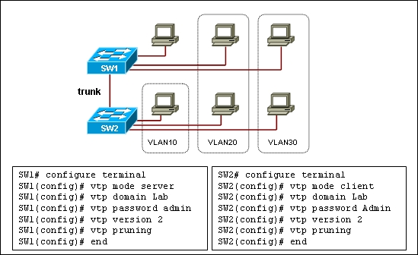

1. Configure the same VLAN's on the VTP client and VTP server.
2. Configure the same VTP mode on the VTP client and VTP server.
3. Configure the same password on the VTP client and VTP server.
4. Configure different VTP domain names on the VTP client and VTP server.
5. Configure the VTP client in VTP transparent mode.
6. Configure the trunk link as an access link.
7. A network engineer is implementing a new V LAN design on an existing structure. The plan is to rename the VTP domain and implement 25 VLAN's. The engineer takes an existing production switch to the lab, enters the proposed VLAN's, and changes the VTP domain name. All new VLAN's are verified present with the **show vlan** command. The network administrator subsequently decides to retain the original domain name, so the name is changed back, and the switch is reconnected to the production network. The **show vlan** command shows that none of the new VLAN's are synchronizing on the other network switches. All switches can ping each other and trunking is correct. What is the likely problem?
8. No ports are assigned to the new VLAN's yet, so VTP pruning is disabling them.
9. The switch rejoined the network with the revision number set to zero.
10. The engineer failed to save the new VLAN configuration to NVRAM.
11. The other switches are all in server mode by default and do not accept VTP updates.
12. Match the description listed on the left to the correct VTP mode. (Not all options are used.)

|  |  |  |  |  |
| --- | --- | --- | --- | --- |
| A. | Create, modify, and delete VLAN's and specify other configuration parameters, such as VTP version and VTP pruning, for the entire VTP domain. | 🡺 |  | VTP Server Mode |
| B. | Forward VTP advertisements that are received out the trunk ports, but cannot advertise and synchronize the VLAN configuration based on received advertisements. | 🡺 |  | VTP Transparent Mode |
| C. | Advertise and synchronize VLAN configuration to other switches in the same VTP domain, but cannot create, change, or delete VLAN's. | 🡺 |  | VTP Client Mode |
| D. | Advertise VTP configuration parameters, such as VTP version and VTP pruning, for the entire VTP domain, but cannot create, modify, and delete VLAN's. | **X** |  |  |
| E. | Cannot forward VTP advertisements nor advertise and synchronize the VLAN configuration based on received advertisements. | **X** |  |  |

1. Refer to the following diagram description to answer this question. There are four switches, Switch1, Switch2, Switch3, and Switch4, interconnected by trunked links and are configured for VTP. A new VLAN is added to Switch1. Which three actions occur? (Choose three.)

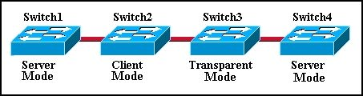

1. Switch1 sends a VTP update to Switch2.
2. Switch2 adds the VLAN to its database and passes the update to Switch3.
3. Switch3 passes the VTP update to Switch4.
4. Switch3 adds the VLAN to its database.
5. Switch4 does not add the VLAN to its database.
6. F.Switch4 does not receive the update.